Breast-Cancer: Supervised Learning

Machine Learning Assignment
- 1858893: Molefe Molefe
- 1390537: Siraj Motaung
- 1814731: Shameel Nkosi

Table of Contents

Overview
- Breast Cancer
- Contribution To Society
Dataset Description
- Attributes & Classes
  - Features and Their Significance
- Hypothesis
Exploratory Data Analysis
- Feature Selection
  - Summary Statistics
    - chi2
- Feature Engineering
  - Imputation
    - Missing Values
    - Fill Most
    - Classifier
Model Analysis & Evidence
- Implementation Details & Hyperparameters
  - Decision Trees
  - Random Forests
  - Naive Bayes
- Accuracy & Errors
  - Confusion Matrix
- Model Comparison
- Cross Validation
Conclusion
Visualisations
Glossary
References

Overview

Breast Cancer

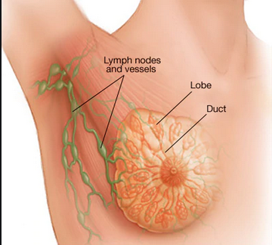

healthline

A familiar problem discussed in the machine learning community is the breast-cancer problem. Cancer occurs when mutations take place in the genes that regulate growth, as well as in the fatty tissue or fibrous connective tissue within a breast.Breast cancer is a cancer that forms in the cells of the breasts and is often difficult to determine whether the cancer is recurrent or not. The recurrency of breast-cancer determines the necessary steps needed by medical professionals to provide the best healthcare treatment.

Recurrent cancer , as suggested by cancer.org, refers to cancer returning to the same location where it is was first discovered(often named after the part where it started). This occurs, after a period of remission, when certain cancer cells in your tissues remain. The faster and bigger the spread, the more difficult it is to treat, and the higher the changes of a recurrence. In the case of a recurrent cancer patient, the procedures become more stringent.Whilst not a popular topic, breast-cancer, according to the Centers for Disease Control and Prevention(CDC), is the most common cancer in women. The cancer forms in the lobules, or ducts of the breasts and the uncontrolled cancer cells invade other healthy breast tissue and can travel to lymph nodes.

Breast-cancer has two categories that reflect the nature of breast-cancer
- Non-Invasisve
  - No Cancer Spread From Original Tissue
- Invasive
  - Cancer Spread From Surrounding Tissue
  - Categorised In Stages

Metastatic breast cancer is another name for stage 4 breast-cancer that spreads from the breasts to other parts of the body such as
- Bones
- Lungs
- Liver

Contribution To Society

Machine learning models engineered for healthcare services are largely crucial in predicting sicknesses, as well suggesting methods best suited to cure or ,at least treat problems related to health. Hence it is imperative that many different models are explored and researched thoroughly enough to make positive changes in people’s lives. Applying the necessary models to the breast-cancer dataset will help notify doctors,physcians and other professionals in the medical field whether a patient will have recurrent or non-recurrent cancer. As such, further deliberations will be appropriately delegated to the eligible entities who have the necessary skills to take care of the patient to best their abilities.

We have written models for this very reason and hope they give some insight to the problem.

Dataset Description

Attributes

The dataset given was obtained from the Institute of Oncology University Medical Center 11 July 1988, provided by Matjaz Zwitter & Milan Soklic (physians).
The dataset consists of categorical variables with 9 features and 1 target variable.

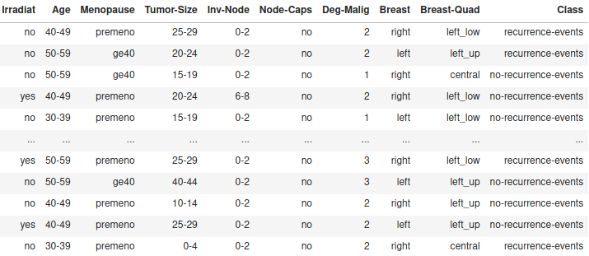

There are 9 missing values in total, Node-Caps having 8 , and Breast-Quad having 1.

Missing values

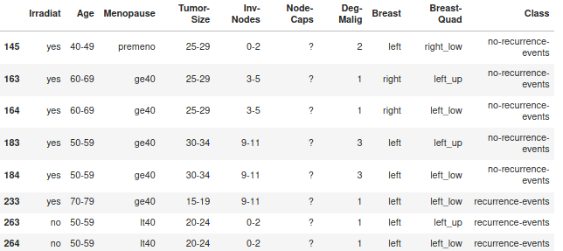
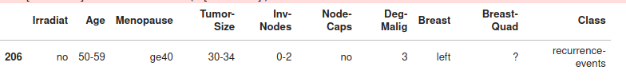

Classes:
Determine whether the cancer is recurring or non-recurring. (Refer to overview for meaning/significance of recurrence)

- There are 286 Total Patients
  - 201 of the patients had non-recurring events
  - 85 of the patients had recurring events

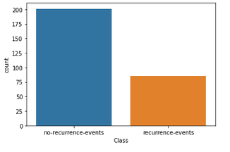

Frequency of Each Feature
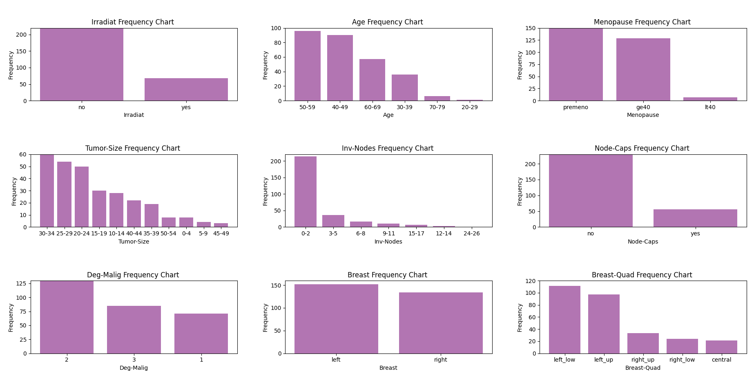

Features:

Radiation is therapy treatment with high-energy rays that destroy cancer cells.
1. Irradiat - refers to the exposure to radiation.

Values
- no
- yes

2. Age frequency – The risk of developing breast-cancer increases as you age. According to another study Pubmed , the mean age of the participants that had a significant appearance was “50 years”

Values
- [20-29]
- [30-39]
- [40-49]
- [50-59]
- [60-69]
- [70-79]

Menopause is the time that marks the end of a woman’s menstrual cycle.

3. Premeno – Premenopause or menopause transition: begins several years before menopause.
The typical age starts at 40.

Values
- Premeno
- lt40
  - Menopause at the age less than 40 at the time of diagnoses
- gt40
  - Menopause at the age greater than 40 at the time of diagnoses

4. DegMalig – Degree of Malignancy in cancer , according to cancerres,
measures the rate of growth,spread, and harm to cells in the body at the time of diagnoses. Grade 3 tumors predominently consist of cells that are highly abnormal

Values
- 1`
- 2
- 3

5. Inv-Nodes – The number of auxilliary lymph nodes that contain metastatic breast-cancer visible on historical examination

Values
- [0-2]
- [3-5]
- [6-8]
- [9-11]
- [12-14]
- [15-17]
- [24-26]

6. Tumor-Size – The greatest diameter (in mm) of exercised tumor

Values
- [0-4]
- [5-9]
- [10-14]
- [15-19]
- [20-24]
- [25-29]
- [30-34]
- [35-39]
- [40-44]
- [45-49]

7. Breast-Quadrant - The breast divides into four quadrants, using the nipple as the central point

Values
- Right Low
- Right Up
- Left Up
- Left Low
- Central

8. Node-Caps – If the cancer does metatstatise to a lymph node, outside of the original site of the tumor

Values
- No
- Yes

Hypothesis
- Recurrence Is Highly Dependent On These Features
  - Irradiat
    - Exposure to radiation increases changes of developing breast-cancer
      - Such as Hodgkin’s disease
  - Age
    - Evidence suggests that as a person gets older, their risk of breast-cancer increases
- Recurrency Is Not Dependent On
  - Breast-Size
  - Menopause
    - Often related to weight

Exploratory Data Analysis

Feature Selection

Feature selection helps to eliminate collinear variables, and reduce the noise in the data. The resulting dataset is a reduced dataset with more significant features.

Recall that the dataset contains categorical variables which would mean that the graphical representation, in regards to plotting and visualising the data, is quite nuanced, and difficult to imagine. Also, they are best described in a table. Futhermore, applying summary statistical methods to select the most important features is different from continuous variables. Whereas with continuous variables one would require some kind of principal component analysis that involves using standardization and/or normalization to perform feature selection.

Feature selection with categorical variables is approached differently, such that the variables are encoded so that a statistical method can be applied to determine a relationship between features, or the lack thereof. The method that was used in the model to solve the breast-cancer problem, is called the chi-squared distribution

Chi-Squared

- machinelearningmastery.com
- reed.edu

Pearson’s chi-squared statiscal hypothesis test is an example of a test for independence between categorical variables.
The test assumes the null hypothesis that the observed frequencies for a categorical variable match the expected frequencies for the variable. The test calculates a statistic that has a chi-squared distribution.
The degrees of freedon for the chi-squared distribution is calculated based on the size of the contigency table as (rows -1 ) * (col – 1).
The results of this test can be used for feature selection, where those features that are independent of the target variable can be removed from the dataset.

Highest contribution
Chi-Squared Results

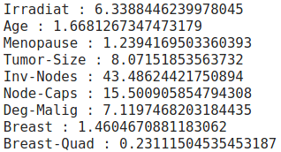

Feature Selection Results

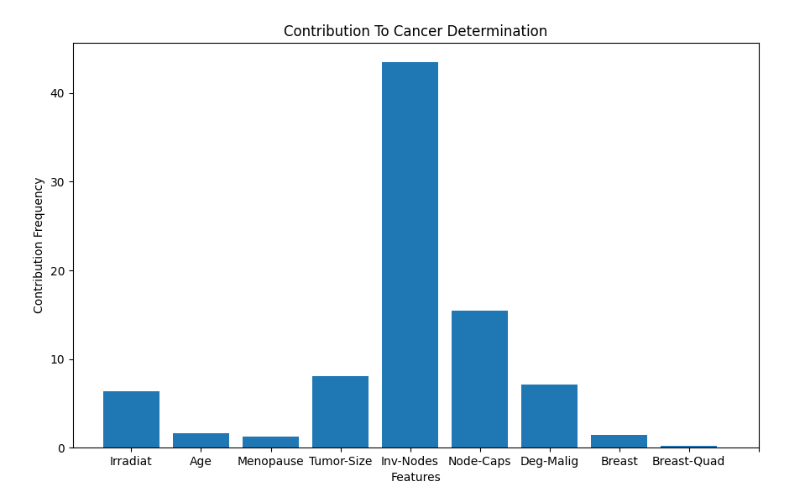
Post-Visualisation Feature Selection

The five features that have the most anticipated contribution are
- Inv-Nodes
- Irradiat
- Node-Caps
- Deg-Malig
- Tumor Size

The results indicate that Node-Caps and Inv-Nodes contribute the most towards cancer recurrence. Age does not seem to have as much of an impact as stated in the hypothesis, at least not the dataset provided.

Feature Engineering

Feature engineering is the process of preparing the dataset to be compatible with machine learning requirements to improve the performance of machine learning models.

The feature engineering technique imputation was used to handle missing values.

Imputation Methods Used
- Ignore Missing Values
- Replace With Most Frequent Values
- Applying Classifier To Predict Values

* Results of the following are found at the Machine Learning Models Section *

1. Ignore Missing Values
This requires that you delete values that appear to have nulls or “zeros” at the data points. This is dangerous because important information might be deleted and impact the accuracy of the model. The only time it is wise to use this method is if a dataset contains lots of information(million datapoints) , since the dataset provided is quite small(286 instances), it is not a surprise if it performs less than other methods.

2. Replace With Most Frequent Values
This requires that you replace the null values with the most occuring value in that column. This is problamatic because it is “naive” and creates an unbalanced dataset that is bias to a particular decision.

3. Applying Classifier To Predict Values
This requires that you apply a learning algorithm to predict the value of the null value. Any method could’ve been used, we chose to use naive bayes and decision trees to predict the values. This required that you reorganize the data such that all null values were regarded the test dataset

Machine Learning Models

Algorithms Chosen
- Decision Trees
- Random Forests
- Naive Bayes

Note
The models are compared based on the number of features being used.
The comparisons are between : feature selected attributes and the full feature attributes of the dataset

Decision Tree

Decision Trees are supervised learning algorithms that are used for classification and regression tasks referred to as CART(classification and regression), classification in this instance. The main idea is to find descriptive features that contain the most infmormation and split dataset along these values. This algorithm is known as a greedy algorithm since it subdivides groups recursively

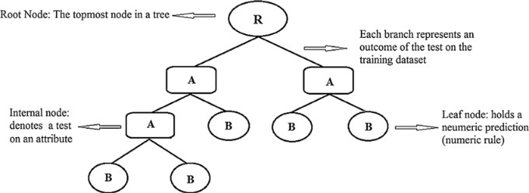

Hyperparameters
- Algorithm
  - ID3: Iterative Dichotamizer
- Impurity Measure
  - Entropy & Feature Gain
- Pruned Node
  - Class = Non-Recurrent Event
  - Reason
    - Occurs Most Frequently In The Dataset
  - Cost
    - Creates Unbalanced Dataset
    - Slightly Impacts The Accuracy
- Depth & Width
  - Max Depth
    - None
      - Nodes expanded until all leaves are pure
- Stopping Criteria
  - Size of Dataset = 0
  - Size of Features = 0
- Feature Size
  - Feature Selected Size = 5
    - After feature selection
  - Full Feature Size = 9
- Random State = 1
  - Keeps Data From Bias
- Dataset
  - Dataset Size = 286
    - Recurrent Events = 85
    - Non-Recurrent Events = 201
  - Missing Values
    - Node-Caps Missing Values = 8
    - Breast – Quad Missing Values = 1
  - K-Fold Cross Validation
    - K = 5

Random State vs Normal State

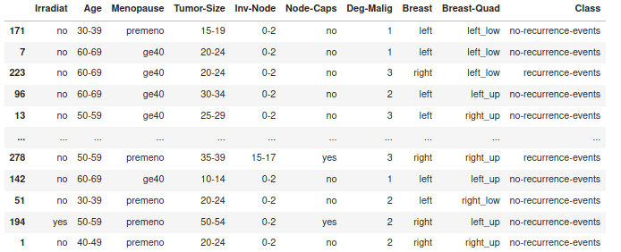
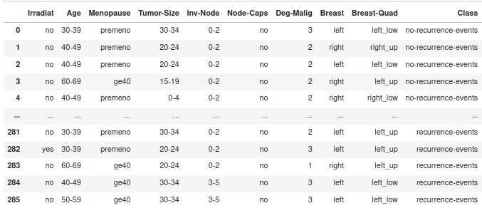

Accuracy

1. Ignore Missing Values

Drawbacks
- Important Information Deleted
- Changed the tree structure
One Iteration Metrics

Accuracy: 67.86 %

Error: 32.14 %

Cross Validation Metrics

Accuracy: 66.4775 %

Error : 33.5225 %

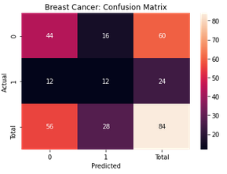

Feature Selected Model

One-Iteration Metrics

Accuracy: 69.05 %

Error: 20.95 %

Cross Validation Metrics

Accuracy: 67.7625 %

Error : 32.2375 %

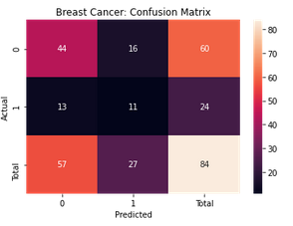

2. Replace With Most Frequent Values

Results

One Iteration Metrics

Accuracy: 72.09 %

Error: 27.91 %

Cross Validation Metrics

Accuracy: 66.085 %

Error : 33.915 %

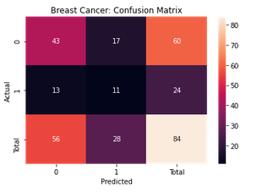

Feature Selected Model

One Iteration Metrics

Accuracy: 69.77 %

Error: 20.23 %

Cross Validation Metrics

Accuracy: 66.0825 %

Error : 33.9175 %

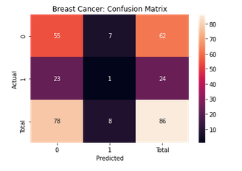

3. Applying Classifier To Predict Values

Advantages
- Learnt the missing values
- Relatively balanced, in comparison to above methods

Disadvantages
- Computationally Expensive
  - Run model to find missing values and to classify dataset

One Iteration Metrics

Accuracy: 66.28 %

Error: 33.72 %

Cross Validation Metrics

Accuracy: 62.575 %

Error : 37.425 %

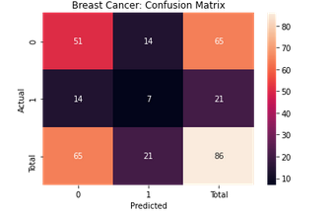

Feature Selected Model

Advantages
- Using Important Features

One Iteration Metrics

Accuracy: 72.09%

Error: 27.91 %

Cross Validation Metrics

Accuracy: 66.155 %

Error : 33.845 %

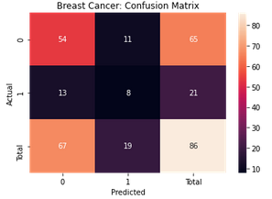

Decision Tree Analysis

Decision was chosen to build the model because they are easy to understand and interpret, Since the features are categorical, classification with decision trees can be implemented much easier than other methods, such as logistic regression

Ignoring the missing values had the most consquential impact on the overall accuracy of the dataset, only showing results of 65.48 %. This proves that some value(s)that had some significance to the overall classification of the dataset were removed.

The last method proves to be the best, where a classifier learnt the missing values and the best features were selected.

Random Forest

Random forests are a supervised learning algorithm that buids a forest. A forest that consists of a large number of inidividual decision trees that operate as an ensemble, and trained using a “bagging” method. Bagging refers to combining learning models that increase an overall result. Random forests aggregrate decisions created by the decision tree to generate predictions.

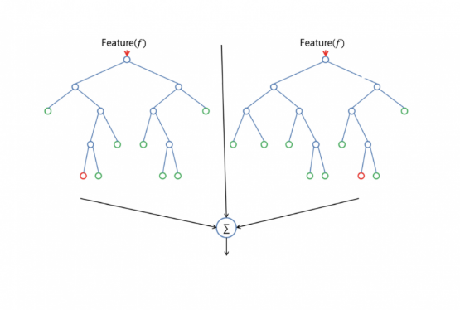

Hyperparameters
- Algorithm
  - Random Forest
  - Bootstrapping
    - Randomizing Dataset & Random Selecting Features
  - Bagging
    - Aggregrating Decision Trees
  - Trees
    - 20 trees
  - K-Fold Cross Validation
    - K= 5
- Decision Tree
  - Impurity Measure
    - Entropy & Feature Gain
  - Pruned Node
    - Class = Non-Recurrent Event
    - Reason
      - Occurs Most Frequently In The Dataset
    - Cost
      - Creates Unbalanced Dataset
      - Slightly Impacts The Accuracy
  - Depth & Width
    - Max Depth
      - None
        - Nodes expanded until all leaves are pure
  - Stopping Criteria
    - Size of Dataset = 0
    - Size of Features = 0
  - Feature Size
    - Feature Selected Size = 5
      - After feature selection
    - Full Feature Size = 9
    - Random State = 1
    - Keeps Data From Bias
  - Dataset
    - Dataset Size = 286
      - Recurrent Events = 85
      - Non-Recurrent Events = 201
    - Missing Values
      - Node-Caps Missing Values = 8
      - Breast – Quad Missing Values = 1

Accuracy Analysis
Cross-validation is a statistical method used to estimate the skill of machine learning models. K-Fold Cross-validation is a resampling procedure used to evaluate machine learning models by splitting the dataset into k groups and performing model analysis on each group.

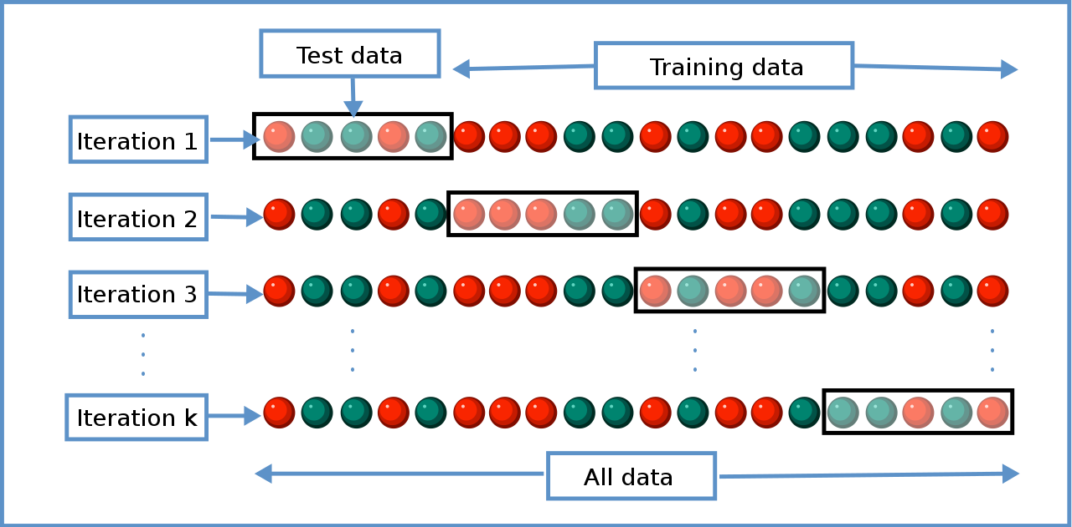

1. Ignore Missing Values

Precision: 75 %

One Iteration Metrics

Accuracy:76.19 %

Error :23.81%

Cross Validation Metrics

Accuracy: 72.955 %

Error : 27.045 %

Feature Selected Method

Precision: 65.8 %

One Iteration Metrics

Accuracy:85.71 %

Error :14.29%

Cross Validation Metrics

Accuracy: 71.8175 %

Error : 28.1825 %

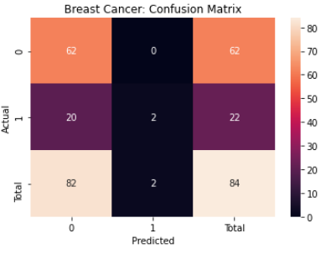

2. Replace With Most Frequent Values

Results

Precision: 45.5 %

One Iteration Metrics

Accuracy:68.6 %

Error :31.4%

Cross Validation Metrics

Accuracy:70.32 %

Error :29.68 %

Feature Selected Method

Precision: %

One Iteration Metrics

Accuracy:68.6 %

Error :31.4%

Cross Validation Metrics

Accuracy: 70.2125 %

Error : 29.7875 %

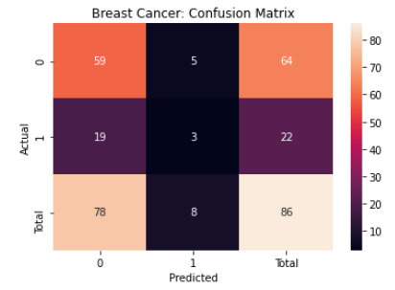

3. Applying Classifier To Predict Values

Precision: 80.0%

One Iteration Metrics
Accuracy:75.58%
Error :24.42 %

Cross Validation Metrics

Accuracy: 70.8675%

Error : 29.1325 %

Feature Selected Method

Precision: 75.0 %

One Iteration Metrics
Accuracy:75.58%
Error :24.42 %

Accuracy:70.4325 %

Error :29.5675 %

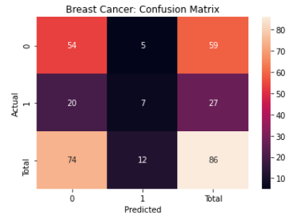

Random forests were chosen for the second algorithm because it is built on top of decision trees, so since we had already chosen decision, that makes the implementation of random forests easier. Also, random are quite flexible such that they randomize the selection of the features to ensure that the dataset does not become bias to a particular result.

The worst performance , in random forest’s case, was ignoring missing values with the all the features present.

The best performance was ignoring the missing values with feature selected attributes, this is due to the fact that values do not need to be pruned since they are aggregrated

Random forest prove to better than decision because random forests avoid the decision tree’s pruning problem by aggregrating leaf nodes to “generalize” the result.

Naive Bayes

Naive Bayes is a supervised learning algorithm that aims , like other algorithms, to predict a value for a new data point, but through calculating the probability of the outcome. It does this in a Naive manner, the Naive part being that it treats every feature as if it were independent of the other features. This works well because you can even remove a certain feature and you’d still be able to get reliable results. We however only removed certain features that contributed less in the overall outcome after engineering the features as mentioned above.

Hyperparameter
- Algorithm
  - Prior probability
  - Posterior Probability
  - Likelihood (main focus)
  - Normalization term
- Naive Bayes
  - Type of Dataset
    - Missing value occurences removed
    - Missing values replaced by most occuring value in the feature
    - Missing values generated by passing the data into a classifier
  - Number of iterations
    - Used to calculate averages
    - Shuffling the dataset at each iteration
      - Improves accuracy
    - Cost
      - The higher the number the of iterations the slower the algorithm
      - Improves accuracy
  - Features
    - Number of features
      - All 9 features vs 5 most contributing found through Chai Square algorithm
      - size of each feature
        - The higher the size of each feature the lesser the accuracy

Accuracy Analysis
We measure the accuracies of 6 different types of the exact same datasets. These are merely huge subsets of the same dataset. There are 2 different datasets in each of three categories below. Upon completing feature engineering, we were able to determine which features contribute the least and we removed them to measure the accuracy of the datasets with missing features and ones without any missing features. Hence the 2 types of datasets in each category.

1. Ignore Missing Values

a. Dataset with all features

One Iteration Metrics

Accuracy:74.6 %

Error :25.4%

Averages

Accuracy: 73.5 %

Error : 26.5 %

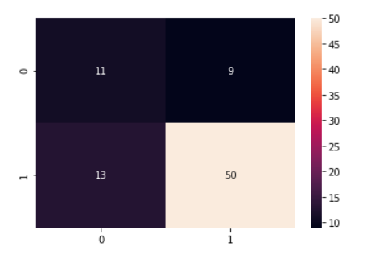

b. Feature Selected Method, Features:

One Iteration Metrics

Accuracy:75.8 %

Error :24.2%

Averages

Accuracy: 74.4 %

Error : 25.6

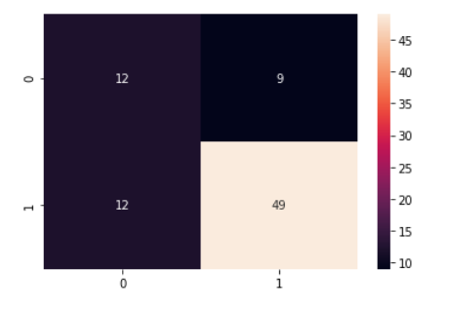

2. Replace With Most Frequent Values

a. Dataset with all features

One Iteration Metrics

Accuracy:70.61 %

Error :29.39%

Averages

Accuracy: 71.76 %

Error : 28.24%

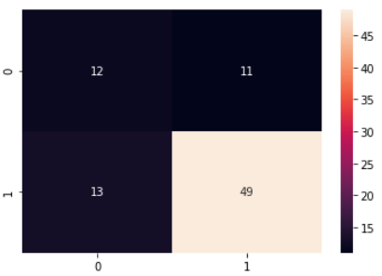

b. Feature Selected Method, Features:

One Iteration Metrics

Accuracy:74.4 %

Error :25.6%

Averages

Accuracy: 75 %

Error : 25%

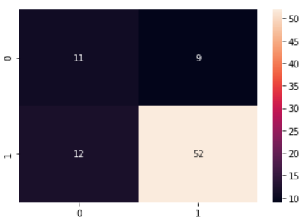

3. Applying Classifier To Predict Values

a. Dataset with all features

One Iteration Metrics

Accuracy:69.72 %

Error :30.28%

Averages

Accuracy: 70.23 %

Error : 29.77%

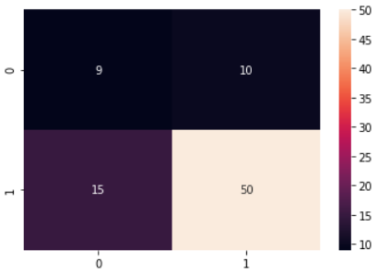

b. Feature Selected Method, Features:

One Iteration Metrics

Accuracy:73.41 %

Error :26.59%

Averages

Accuracy: 72.62%

Error : 27.38%

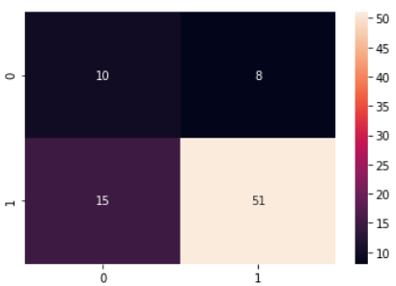

Conclusion & Modal Comparison

What what is better because this and that

Scores from other people
-

Resources
- towardsdatascience.com
- visualstudiomagazine.com
- Dataset
  - https://archive.ics.uci.edu/ml/machine-learning-databases/breast-cancer/
Glossary
- lobules
  - A gland that produces milk
- lymph nodes
  - Small glands that filter lymph
- lymph
  - Clear fluid that circulates through the lymphatic system
- metastatic
  - Spread of cancer cells to new areas of the body
- collinear variables
  - One predictor variable can be linearly predicted from other variables
- Pruning
  - Remove sub nodes
    - Often because there are out-voted by other similar nodes
- Greedy Algorithm
  - Algorithma that builds up solution piece by piece.

